Ron Vincent Cada
Student Enrollment Database – Design, Build & Query

PART 1 – Schema Design & Creation
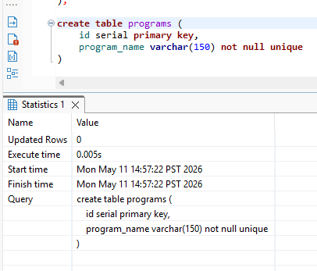
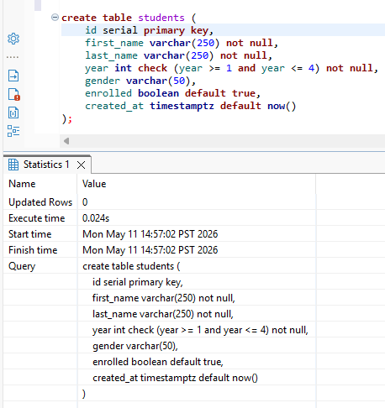
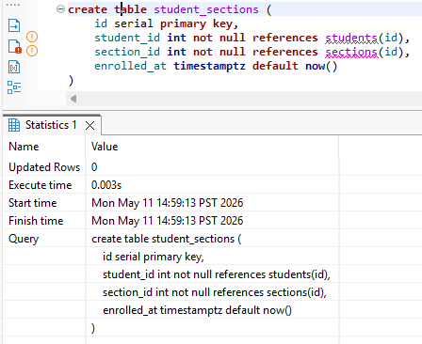
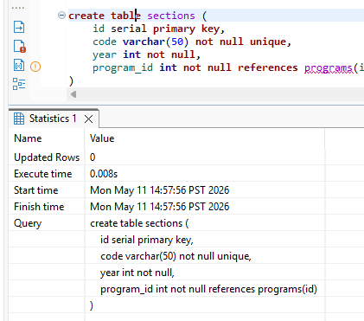

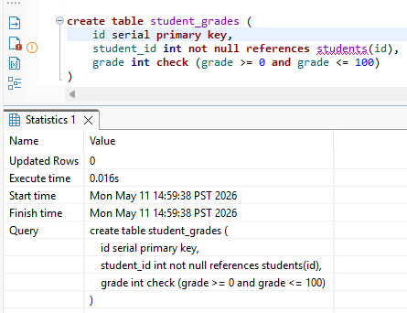

PART 2 – Seed Data & INSERT
Insert data in students table
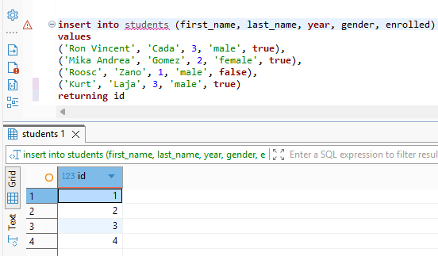

Verify the count of the students table
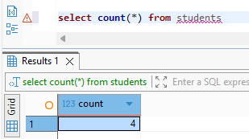

Insert data in programs table
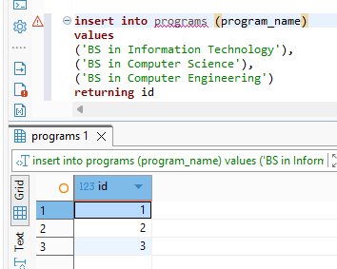

Verify the count of the programs table
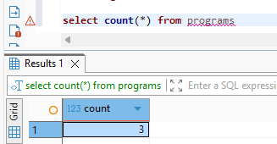

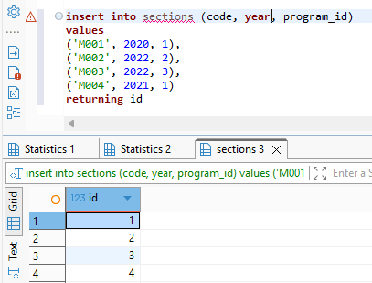
insert data in sections table

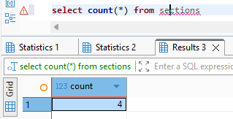
verify the count of sections table

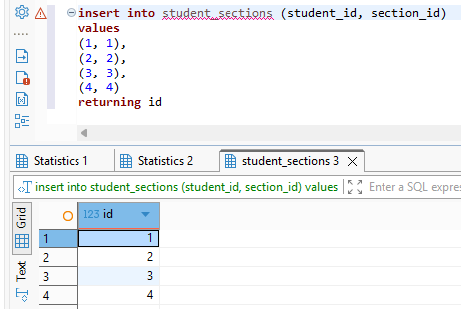
Insert data in student_sections junction table

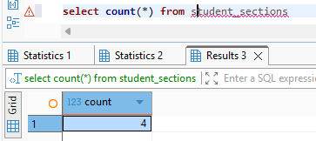
Verify the count of student_sections junction table

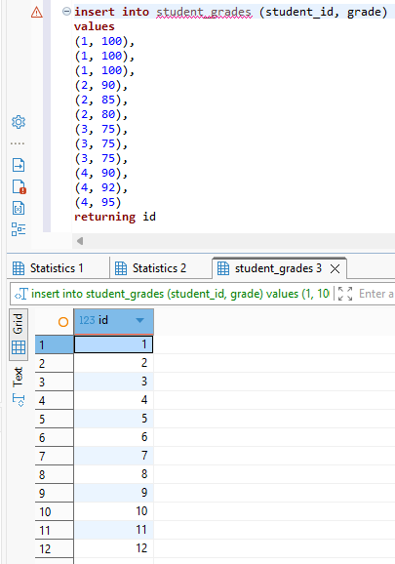
Insert data in student_grades

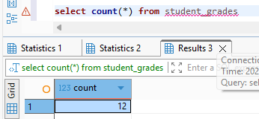
Verify the count of student_grades

Part 3 – Queries
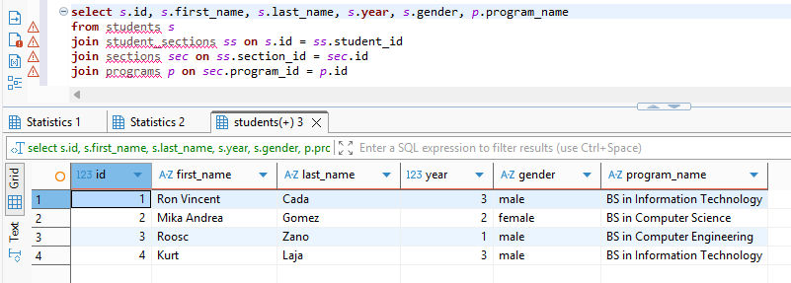
display all students with their program names

display students with their assigned section codes
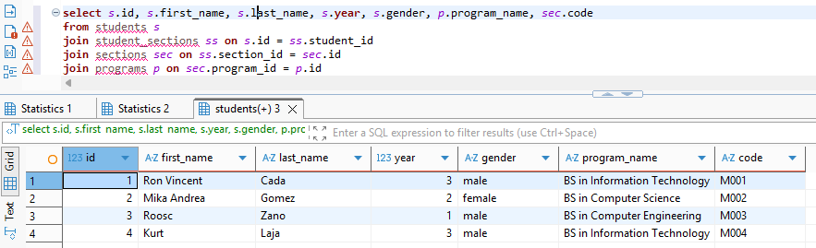

Retrieve all the currently enrolled students
In here student Roosc Zano is not shown since he is not enrolled
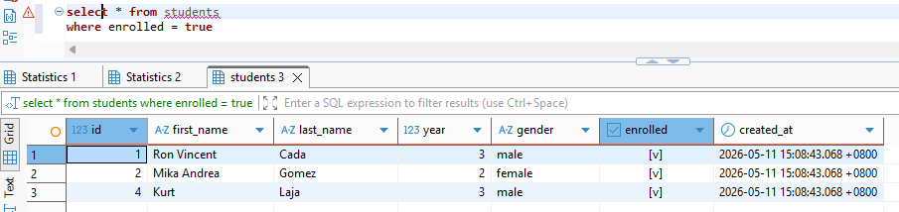
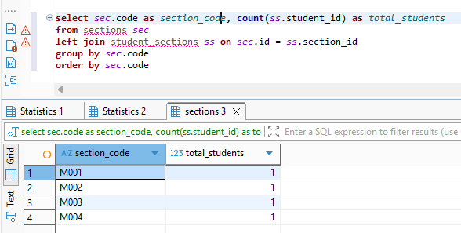
Count the number of students per section using GROUP BY

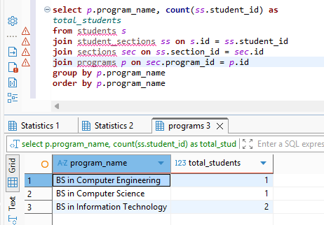
Count the number of students per program

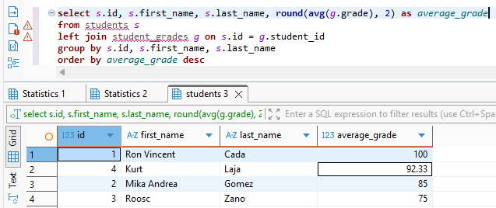
Computing the average grade of each student using AVG

Finding students who are not assigned to any section using LEFT JOIN with IS NULL
In here there are no students found with no sections assigned
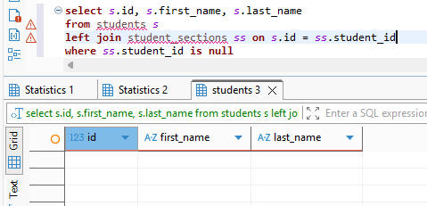

Finding sections with no students assigned
In here there are no sections found with no students assigned
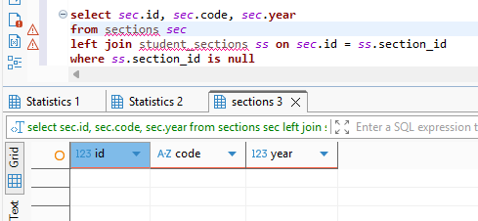

PART 4 – Indexes & Constraints
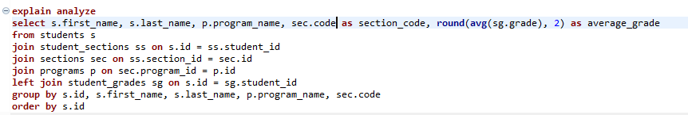

Before creating Indexes
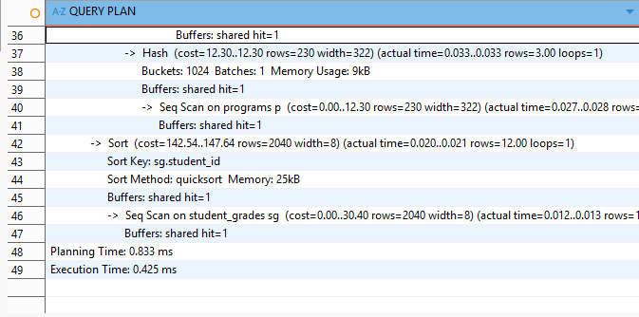

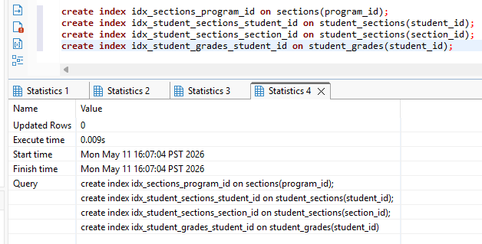
create indexes

After creating indexes
